ASN Technical Gap Analysis – November 2007

Background

Mars Australia and Trade aligned over long term adoption of electronic trading
To respond to competitive pressures the Australian retail trade is forcefully implementing a program of supply chain efficiency initiatives. One area of particular interest, is the adoption of electronic Business to Business trading (eB2B). eB2B covers the ability to electronically order, receipt, invoice and pay for goods. eB2B transactions include:
- Purchase Orders (PO): customer request for desired quantity of items at a pre-agreed price
- Purchase Order Acknowledgement (POA): supplier commits to the quantity they can supply
- Advance Shipping Notice (ASN): supplier notifies customer of actual quantities despatched
- Pallets labelled with Serial Shipping Container Codes (SSCC) outlining quantities and items
- ASN Discrepancy Memo (ADM): identifies errors in ASN details versus actual goods received
- Electronic Invoicing (e-Invoicing): supplier creates invoice based on PO prices and ASN quantities
- Recipient Created Tax Invoice (RCTI): customer creates invoice based on PO prices and ASN quantities
- Remittance Advice (RA): electronic payment referenced to ASN (or if unavailable to invoices)

While being requested by the trade, implementation of these initiatives are aligned with the business focus on “World Class Supply Chain” and will result in efficiency gains in the Mars supply chain.

Trade Partner Integration completed for enablers and ordering
Trade Partner Integration (TPI) is the term used to describe the set of Mars projects aimed at achieving eB2B. There has been continual progress towards TPI, with a current status outlined below:
- All sites have implemented the necessary enablers for eB2B
- SSCC labels (an enabler for ASN)
- EDI messaging format (upgraded from EANCOMM97 to EANCOMM2002)
- EDI messaging system (upgraded from Amtrix to SAP XI)
- Electronic ordering (PO and POA) has been implemented
- ASN and ADM are partially implemented
- Food is capable of using ASN for all customers, but has been enabled for Big W (DTS) only
- E-billing (RCTI, e-invoicing and RA) have not been implemented

Mars is currently becoming CMT compliant
To facilitate the introduction of eB2B, both WOW and GHPL have outsourced the task of systems testing to an independent company, GS1. To be certified as eB2B compliant, suppliers must use GS1’s electronic message test system, the Community Management Tool (CMT). Once suppliers have completed all the tests in CMT they are then able to engage with customers and fully implement their eB2B solution.

A Mars project team, sponsored by Garry Shields, is currently completing the CMT compliance project from a technical IT perspective. As part of this process they are validating that the EDI messages that are being created have not been compromised by:
- The upgrade from EANCOMM97 / Amtrix to EANCOMM2002 / SAP XI
- ATLAS template and Masterdata changes

NOTE: Whilst Mars will be technically compliant, it must be made absolutely clear that Mars will not be able to implement its eB2B program until the necessary business compliance (i.e. process change) is achieved. There is currently no agreed go-live date on eB2B.

Recognition of issues in current ASN implementation
The recent activity associated with the CMT compliance project, has increased the business’ awareness of the potential technical and business issues inherent in the delivery of ASN’s. It is clear that these issues will need to be resolved prior to “Go Live” across all segments. These issues are discussed in more detail in the following section.

Rationale for Technical ASN Gap Analysis

ASN business gaps recognised, but they are Out Of Scope of this review
Discussions with Associates have identified a number of different perspectives on the acceptability of the current ASN implementation and the rate at which we should go-live. These are outlined in more detail in Appendix A. Whilst we recognise the validity of business concerns in the current ASN implementation, it is beyond the current scope of this review.

ASN technical gaps are the key focus of this review
The current ASN solution was developed to meet the immediate tactical needs of making Direct To Store deliveries to Big W for the Food segment (see Appendix B for current ASN Architecture). However, in the interim period a number of changes have been made that may impact on the ability of the current solution to work across all the Australian Mars businesses:
- The upgrade from EANCOMM97 / Amtrix to EANCOMM2002 / SAP XI
- ATLAS template and Masterdata changes
- Operational differences between Food, Snackfood and Petcare
- Differences in TOLAS configurations between Food, Snackfood and Petcare

The scope of this technical review concerns the questions:
- Which changes have impaired the accuracy and effectiveness of the current ASN implementation?
- What do we need to do to become rectify these issues?
- What is the cost and timelines associated with this compliance program?

Working Session Issues
The following areas have been identified as possible issues. The purpose of the working session on 26th November will be to investigate and gain a common understanding and prioritisation.

Area | Potential Issue
ASN message structure | - ASN message format for GHPL differs from WOW. By extension, we can anticipate that each customer may have a unique ASN message format
EDI | - Move from EANCOMM97 / Amtrix to EANCOMM2002 / SAP XI
ATLAS Template changes | - ?
Operational differences between segments | - Snack: Delivery number can have multiple sales orders attached (eg see Delivery 4 in Appendix B). This is an anticipated situation from the ATLAS template team, but the LADS/ICS implementation of ASN was working under the assumption that a delivery number has only one sales order  - Pet: use of handling units versus trading units  - ? Other ??
TOLAS differences | - Snackfood?  - Petcare?
Food issues | - Currently the image quality of the SSCC printers are not sufficient to allow for accurate bar code readings (R&D investigating)  - The ASN routines have failed in certain circumstances … what were these?
Other?

Appendix A: Rationale for ASN Gap Analysis on Business Issues

Only GHPL pushing to go-live with ASN

ASN’s are a key plank for RCTI, but not mandatory in e-invoicing
- Electronic Billing with our customers can occur in two ways: RCTI or e-Invoices
- RCTI’s must have the required ASN functionality in place. An RCTI, is initiated by the customer (eg GHPL) and uses the information provided by the ASN’s to generate the invoice. Conversely, e-invoices are generated by the supplier (Mars) and are matched to the PO or the ASN
- Tax advice suggests Mars Australia must adopt RCTI simultaneously across all three segments

From a customer perspective only GHPL are pushing for adoption of ASN
- GHPL is taking a very hard line and is mandating RCTI for all their B2B vendors. Their experiences with Kmart and Officeworks indicate the potential savings to GHPL from RCTI will be higher than e-Invoicing, and consequently GHPL are pushing their vendors towards RCTI
- WOW is strongly pursuing a B2B solution with vendors, but are experiencing issues with the rollout of ASN. As e-invoicing does not require the implementation of ASN’s, WOW probably have a preference for the adoption of e-invoicing at this stage
- Metcash and our other customers are unlikely to push for adoption of RCTI, and by inference ASN’s are unlikely to be a mandatory requirement in the short term

Differing perspectives on requirement to go-live with ASN

Logistics indicate a need to adopt a measured and deliberate implementation
Logistics Associates have communicated:
- A lack of a sense of urgency from the customers on ASN; They have not had communications with WOW or GHPL that demand immediate progress or implementation of ASN or RCTI
- The need for substantial customer dialogue to understand the customer rationale and implications on customer operations
- Business resources need to commit sufficient time and effort to reviewing “as-is” and “to-be” processes, including all standard and non-standard variants (eg including failures)

Petcare Customer Service have experienced pressure from GHPL to go-live
There have been a series of discussions on eB2B held with WOW and GHPL over the last 2 years, and there is a growing sense that Mars needs to commit to a firm timeline for delivery ASAP.

Finance benefit from e-billing, but don’t need ASN and RCTI to gain these benefits
- Finance are keen to adopt either e-billing approach (RCTI or e-invoicing)
- Business benefits are realised through faster collection of cash, reduced returns/demurrage from customers warehouse as deliveries have been pre-approved, less time spent by accounts on customer enquiries/disputes, and decreased postage costs
- Based on estimates gathered in December 2006, the savings are anticipated to be in the order of $65-75K pa and $1.6m lower Assets
- RCTI would save an additional $15K pa due to a reduction in claims as pricing is agreed in advance, however neither vendor has successfully adopted the enabling tool (EANnet)
- More than offsetting the above benefit, RCTI has an uncertain (and potentially costly) development path that would need to be undertaken (Dec 2006 findings)
- However, Finance will need to offer both RCTI and e-invoicing
- Whilst GHPL are adamant on RCTI, WOW has offered both approaches
- Smaller customers are unlikely to be able to handle the sophistication required to adopt RCTI
- As RCTI and ASN require substantial technical and business developments to take place, Finance are best placed to focus on delivering the benefits from e-invoicing first before ASN and RCTI

Current ASN solution has unacceptable reliance on TOLAS
The current ASN implementation relies on TOLAS output queues. Issues include:
- Any delivery from a non-TOLAS site will be unable to produce an ASN. This will include instances where deliveries have been initially sent from a TOLAS site but were rejected by a customer and have returned to a non-TOLAS warehouse for later delivery
- TOLAS is currently under review and one of the early principles of the ATLAS visioning process was to utilise global applications wherever possible. At the time of implementation, use of TOLAS for generation of the ASN was seen as a tactical solution.

Appendix B: Current ASN Implementation

The diagram below outlines the ASN architecture.
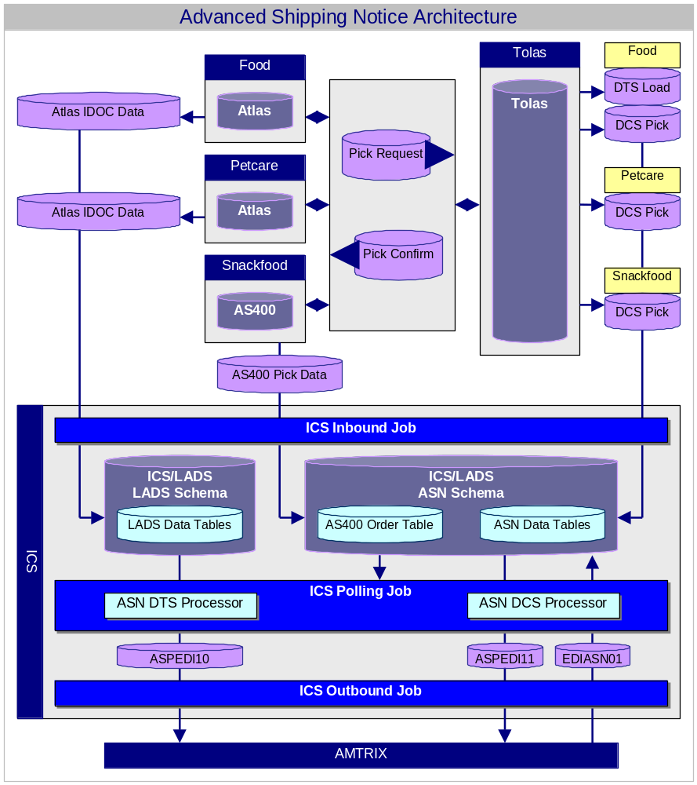
Changes since the architecture was put in place include:
- Snackfood discontinued AS400 and now uses ATLAS IDOC data and ICS/LADS LADS schema
- AMTRIX replaced by SAP XI

